User Assignment Rules Solution

Exercise 1: Investigation

4.

* 1. Did two of the five assignments go to Thomas Sanders? Yes
  2. Did two of the five assignments go to Faith Thomson? Yes
  3. Did one of the five assignments go to Sylvia Ulveling? Yes
  4. Did any assignment go to Pam Vance or Kerrie Winslow? No

Exercise 2: Configuration

Requirement 1: Assigning FNOL Error Activities to Claim Creator

This rule must be created in the Global Activity Assignment rule set.

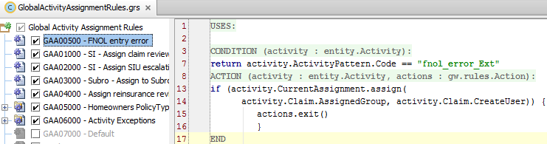

Requirement 2: Assigning Vandalism Claims Manually

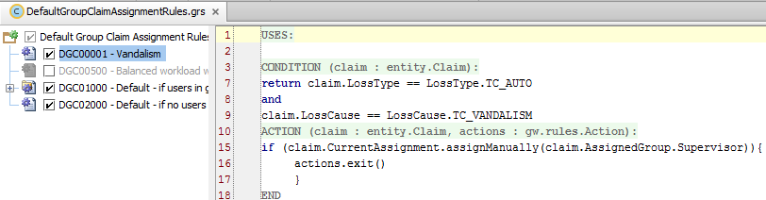

Requirement 3: Assigning Activities to a Group’s Queue

